 **NAME: ____________________________**

**UNITS 3 & 4 Practice Examination**

**VCE**®**Mathematical Methods**

**Written examination 2**

**FOR ADJUSTED STUDY DESIGN (2020 ONLY)**

**Reading time: 15 minutes Writing time: 2 hours**

**QUESTION AND ANSWER BOOK**

**Structure of book**

|  |  |  |  |
| --- | --- | --- | --- |
| *Section* | *Number of*  *questions* | *Number of questions*  *to be answered* | *Number of*  *marks* |
| A | 20 | 20 | $$20$$ |
| B | 5 | 5 | $$60$$ |
|  |  |  | $$80$$ |

* Students are permitted to bring into the examination room: pens, pencils, highlighters, erasers, sharpeners, rulers, a protractor, set-squares, aids for curve sketching, one bound reference, one approved CAS calculator or CAS software and, if desired, one scientific calculator. Calculator memory DOES NOT need to be cleared.
* Students are NOT permitted to bring into the examination room: blank sheets of paper and/or white out liquid/tape.

**Materials supplied**

* A question and answer book of 30 pages.
* A double sided page of formulas.
* An answer sheet for multiple-choice questions.

**Instructions**

* Write your name in the space provided above on this page.
* Write your name on the multiple-choice answer sheet.
* Unless otherwise indicated the diagrams in this book are **not** drawn to scale.
* All written responses must be in English.

**At end of Examination**

* Place the answer sheet for multiple-choice questions inside the front cover of this book.

**Students are NOT permitted to bring mobile phones and/or any other unauthorised electronic devices into the examination room.**

**This page is blank**

**SECTION A – Multiple-choice questions**

**Instructions for Section A**

Answer **all** questions in pencil on the answer sheet provided for multiple-choice questions.

Choose the response that is **correct** for the question.

A correct answer scores 1; an incorrect answer scores 0.

Marks will **not** be deducted for incorrect answers.

No marks will be given if more than one answer is completed for any question.

Unless otherwise indicated, the diagrams in this book are **not** drawn to scale.

**Question 1**

$$The period and amplitude of f\left(x\right)=-\frac{1}{4}\cos\left(\frac{x}{2}\right)-3\text{are}$$

|  |  |
| --- | --- |
| **A.** | $$4π \text{and }-\frac{1}{4}$$ |
| **B.** | $$2π and 4$$ |
| **C.** | $$2π \text{and }\frac{1}{4}$$ |
| **D.** | $$\frac{1}{2} and 4$$ |
| **E.** | $$4π and \frac{1}{4}$$ |

**Question 2**

What is the value of the coefficient of $x^{2}$ in the expansion of $\left(x-3\right)\left(x^{3}+3x-x^{2}-2x^{-2}\right)?$

|  |  |
| --- | --- |
| **A.** | -5 |
| **B.** | -2 |
| **C.** | 1 |
| **D.** | 6 |
| **E.** | There is no $x^{2 }$ term in the expansion |

**Question 3**

$$The y-\text{coordinates of the turning points of }f\left(x\right)=\frac{2}{3}x^{3}+x^{2}-24x+4 are$$

|  |  |
| --- | --- |
| **A.** | $$-41 and \frac{220}{3}$$ |
| **B.** | $$-4 \text{and }3$$ |
| **C.** | 0 and 4 |
| **D.** | $$-\frac{100}{3} and 67$$ |
| **E.** | There are no turning points. |

**Question 4**

$g(x)$ was obtained by dilation of $f(x)$ by a factor of 2, parallel to the *x*-axis, and translation of 2 units horizontally and -4 units vertically. If $f\left(x\right)=2\sin\left(x\right)+6$, then the equation of $g(x)$ equals:

|  |  |
| --- | --- |
| **A.** | $$2\sin\left(2\left(x-2\right)\right)+2$$ |
| **B.** | $$2\sin\left(\frac{1}{2}\left(x-2\right)\right)+2$$ |
| **C.** | $$2\sin\left(\frac{1}{2}\left(x+2\right)\right)+2$$ |
| **D.** | $$4\sin\left(x-2\right)+2$$ |
| **E.** | $$4\sin\left(x+2\right)+10$$ |

**Question 5**

What is the value of *a* in $y=-2e^{x}-a$, given the range of *y* is $\left(-∞,4\right)?$

|  |  |
| --- | --- |
| **A.** | $$-4$$ |
| **B.** | $$-2$$ |
| **C.** | $$4-∞$$ |
| **D.** | $$2$$ |
| **E.** | $$4$$ |

**Question 6**

An antiderivative of $2\cos\left(4x\right)-1$ is

|  |  |
| --- | --- |
| **A.** | $$8\sin\left(4x\right)-x$$ |
| **B.** | $$2\sin\left({2x}^{2}\right)-x-1$$ |
| **C.** | $$8\sin\left(4x\right)$$ |
| **D.** | $$\frac{1}{2}\sin\left(4x\right)-x-1$$ |
| **E.** | $$\frac{1}{2}\sin\left({2x}^{2}\right)-x$$ |

**Question 7**

$$y=ax-\frac{3}{4}$$

A normal to $f\left(x\right)=x^{2}-2x-4$ has the equation . What is the value(s) of *a*?

|  |  |
| --- | --- |
| **A.** | $$R\backslash \left\{0\right\}$$ |
| **B.** | $$-\sqrt{3}-2, \sqrt{3}-2 \text{and }\frac{1}{4}$$ |
| **C.** | $$2$$ |
| **D.** | $$-2$$ |
| **E.** | $$\frac{5\sqrt{6}+26}{8} and \frac{26-5\sqrt{6}}{8}$$ |

**Question 8**

What is the maximum domain of $f^{-1}(x)$, the inverse function of

$f:\left(-10,∞\right)→R,f\left(x\right)=x\left(x-2\right)\left(x+2\right)$?

|  |  |
| --- | --- |
| **A.** | $$\left(-\frac{2\sqrt{3}}{3},∞\right)$$ |
| **B.** | $$\left(-\frac{2\sqrt{3}}{3},∞\right)$$ |
| **C.** | $$\left(\frac{16\sqrt{3}}{9},∞\right)$$ |
| **D.** | $$\left(-960,∞\right)$$ |
| **E.** | $$\left(-960,-\frac{2\sqrt{3}}{3}\right)$$ |

*Questions 9 and 10 refer to the following graph.*

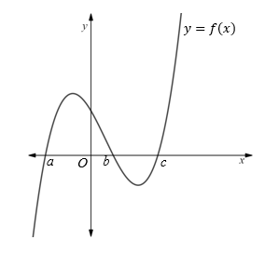

**Question 9**

For the above graph of $y=f\left(x\right),$ which one of the following is false?

|  |  |
| --- | --- |
| **A.** | $f\left(c\right)=0$ and $f^{'}\left(x\right)>0$ when $x>c$ |
| **B.** | $f\left(x\right)<0$ when $x<a$ and $f^{'}\left(x\right)>0$ when $x<a$ |
| **C.** | $f\left(x\right)>0$ when $x>c$ and $f^{'}\left(x\right)>0$ when $x>c$ |
| **D.** | $f\left(b\right)=0$ and $f^{'}\left(x\right)>0$ when $x>a$ |
| **E.** | $f\left(a\right)=0$ and $f^{'}\left(x\right)>0$ when $x>c$ |

**Question 10**

The area bounded by $f(x)$ and the $x-axis$ can be obtained by evaluating which one of the following?

|  |  |
| --- | --- |
| **A.** | $$\int_{a}^{b}{f\left(x\right)dx}+\int_{b}^{c}{f\left(x\right)dx}$$ |
| **B.** | $$\int_{b}^{a}{f\left(x\right)dx}+\int_{c}^{b}{f\left(x\right)dx}$$ |
| **C.** | $$\int_{a}^{b}{f\left(x\right)dx}-\int_{c}^{b}{f\left(x\right)dx}$$ |
| **D.** | $$\int_{a}^{c}{f\left(x\right)dx}$$ |
| **E.** | $$\int_{a}^{b}{f\left(x\right)dx}-\int_{b}^{c}{f\left(x\right)dx}$$ |

**Question 11**

The solutions to the equation, $2\sin\left(\frac{πx}{4}\right)-1=0, 2<x<12$, are

|  |  |
| --- | --- |
| **A.** | $$x=\frac{10}{3},x= \frac{26}{3},x=\frac{34}{3}$$ |
| **B.** | $$x=\frac{2}{3},x= \frac{10}{3}$$ |
| **C.** | $$x=\frac{1}{2}$$ |
| **D.** | $$x=\frac{π}{6}, x=\frac{5π}{6}$$ |
| **E.** | $$x=\frac{2(12n+1)}{3}, x=\frac{2(12n+5)}{3}$$ |

**Question 12**

If a coin is tossed ten times, what is the probability, to four decimal places, that not more than three of the outcomes are heads?

|  |  |
| --- | --- |
| **A.** | 0.0547 |
| **B.** | 0.1709 |
| **C.** | 0.1719 |
| **D.** | 0.8281 |
| **E.** | 0.9453 |

**Question 13**

The mass of wool sheep yield when shorn is normally distributed, with an average of 7.50 kg. If 27% of the sheep in a flock produced between 7.10 kg and 7.50 kg of wool each, the probability that a particular sheep will yield more than 8.25 kg of wool when shorn is closest to

|  |  |
| --- | --- |
| **A.** | 0.5414 |
| **B.** | 0.3090 |
| **C.** | 0.2700 |
| **D.** | 0.0830 |
| **E.** | 0.0148 |

**Question 14**

$\operatorname{Pr}\left(Z>a\right)=m$ and $\operatorname{Pr}\left(Z<b\right)=n$. If $a>b$, then $\text{Pr}(Z<a|Z>b)$ is equal to

|  |  |
| --- | --- |
| **A.** | $$\frac{1-m}{n}$$ |
| **B.** | $$m-n$$ |
| **C.** | $$\frac{1-m}{1-n}$$ |
| **D.** | $$\frac{m+n-1}{n-1}$$ |
| **E.** | $$1-mn$$ |

**Question 15**

The function $y=a\sqrt{x}$ has a tangent at $x=b$ and a normal at $x=4b$ which intersect at the point $(7, 9\sqrt{2})$. What is the value of *a*?

|  |  |
| --- | --- |
| **A.** | 1 |
| **B.** | 2 |
| **C.** | $$2\sqrt{2}$$ |
| **D.** | 3 |
| **E.** | $$4$$ |

**Question 16**

A family of curves has the general equation $y=a\left(x^{2}-x\right)e^{x}, a∈R\backslash \left\{0\right\}$. What is the ratio of the area between the curve (for $x<0)$ and the $x-\text{axis}$ to the area enclosed by the curve

and the $x-\text{axis}$?

|  |  |
| --- | --- |
| **A.** | $$\frac{3}{e-3}$$ |
| **B.** | $$\frac{3}{3-e}$$ |
| **C.** | $$\frac{3-e}{3}$$ |
| **D.** | $$a$$ |
| **E.** | $$∞$$ |

**Question 17**

$$f\left(x\right)=x^{m/n} \text{and }g\left(x\right)=x^{p/q}, m, n,p,q∈N$$

If $h\left(x\right)=f(g\left(x\right))$, which one of the following statements is true?

|  |  |
| --- | --- |
| **A.** | For $n<m \text{and }q<p$ and $x<0,$ then $h^{'}\left(x\right)>0$ |
| **B.** | For $n>p$ and $m<q$ and $x>0$, then $h^{''}\left(x\right)>0$ |
| **C.** | $h(x)$ is defined for $x∈R$ |
| **D.** | $$h^{'}\left(1\right)=\frac{nq}{mp}$$ |
| **E.** | $$For m=q and p=n, \text{then }\left(m,m\right) and \left(n,n\right) are points on h(x)$$ |

**Question 18**

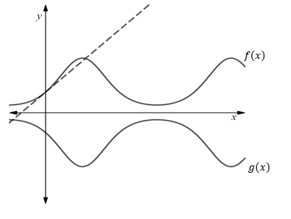

In the graph above, $f\left(x\right)=e^{\sin{(x)}}$ and $g\left(x\right)=-f(x)$. A tangent line to $f\left(x\right)$ at $x=0$ is also shown as a dashed line. What is the angle between the tangent line of $f\left(x\right)$ at $x=0$ and the tangent line of $g\left(x\right)$ at $x=0$?

|  |  |
| --- | --- |
| **A.** | $$\frac{π}{6}$$ |
| **B.** | $$\frac{π}{4}$$ |
| **C.** | $$\frac{π}{3}$$ |
| **D.** | $$\frac{π}{2}$$ |
| **E.** | $$\frac{2π}{3}$$ |

**Question 19**

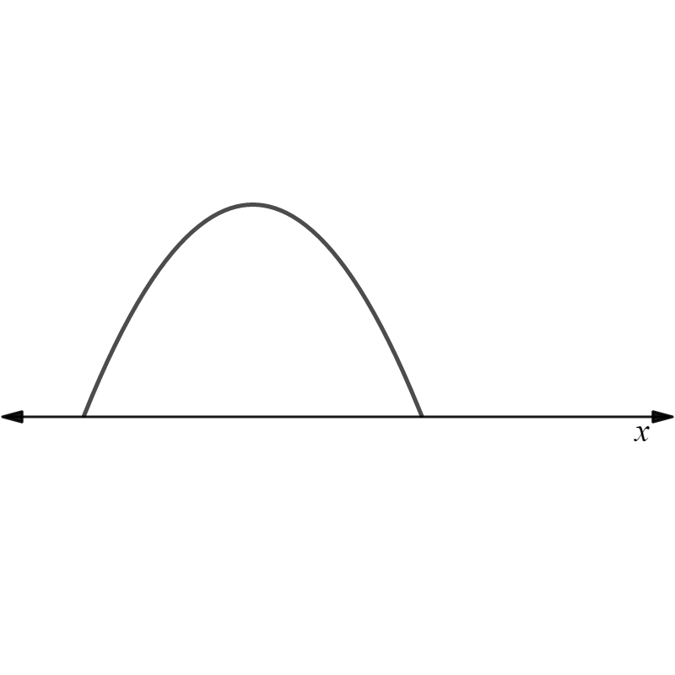

In the above graph, the curved section in modelled by the equation:

$$h:\left[m,n\right]→R,h\left(x\right)=-\frac{1}{16}{\left(x-b\right)}^{2}+c$$

$$\frac{50}{3}$$

The average value of $h(x)$ is . .What is the maximum value of $h(x)$?

|  |  |
| --- | --- |
| **A.** | 25 |
| **B.** | $$b+20$$ |
| **C.** | $$\frac{100}{3}$$ |
| **D.** | $$\frac{25}{3}$$ |
| **E.** | Insufficient information provided since two unknowns. |

**Question 20**

$$\text{If }f\left(x\right)=x^{\frac{1}{3}}, \text{then the graph of }g\left(x\right), \text{where }g\left(x\right)=1-2f\left(1-2x\right) \text{could be}$$

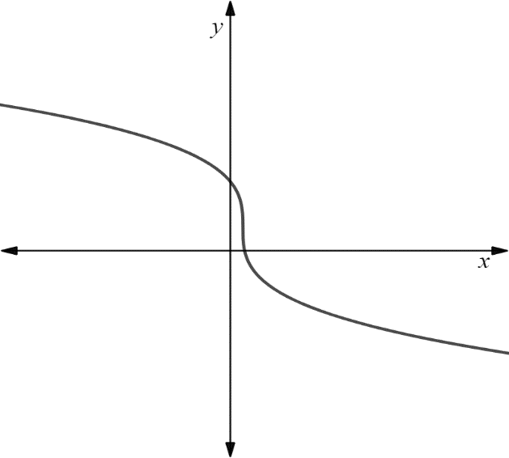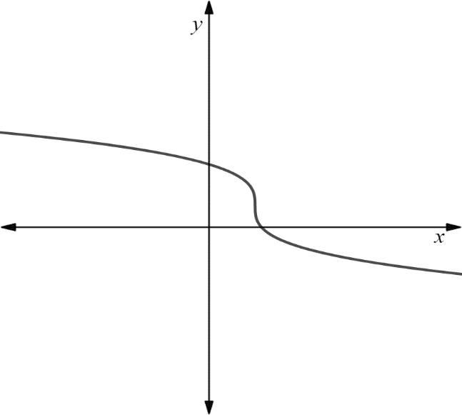

**A**

**B**

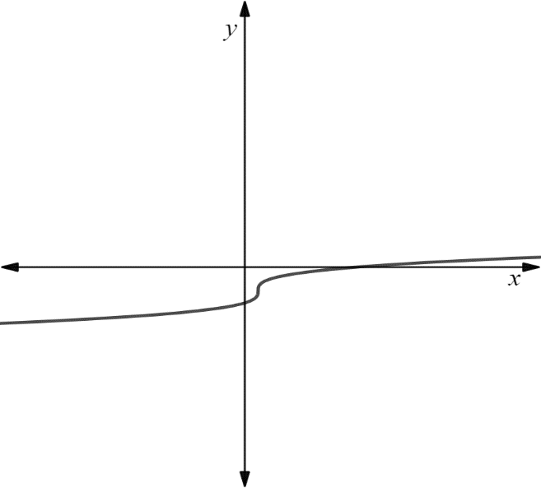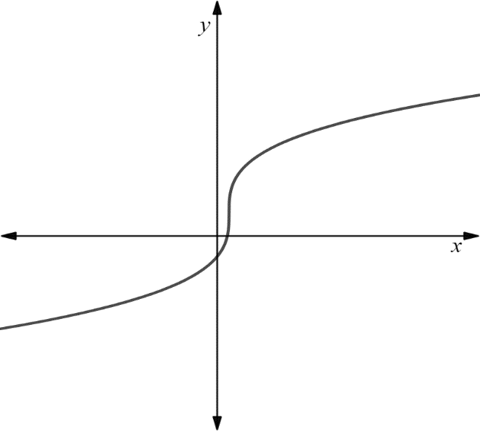

**D**

**C**

**E**

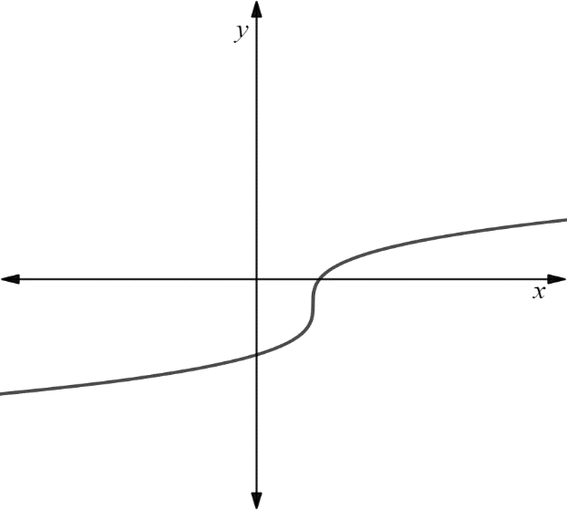

**SECTION B**

**Instructions for Section B**

Answer **all** questions in the spaces provided.

In all questions where a numerical answer is required, an exact value must be given unless otherwise specified.

In questions where more than one mark is available, appropriate working **must** be shown.

Unless otherwise indicated, the diagrams in this book are **not** drawn to scale.

**Question 1** (10 marks)

Let $f:\left(a,b\right)→R:f\left(x\right)=x\log_{e}\left(x\right)$

1. **i.** Find *a*, such that $f(x)$ has a maximum domain. 1 mark

|  |
| --- |
|  |
|  |

**ii.** Find $f'(x)$ 1 mark

|  |
| --- |
|  |
|  |

**iii.** Hence find the coordinates of the stationary point and state its nature. 2 marks

|  |
| --- |
|  |
|  |

‘

1. Differentiate $x^{2}\log_{e}\left(x\right)$ and hence find the antiderivative of $f(x)$. 3 marks

|  |
| --- |
|  |
|  |
|  |
|  |
|  |
|  |

1. Let $\left(k,0\right)$ be the $x-$ intercept of $f(x)$. Let $(m,n)$ be a point on $f(x)$

where $m>k$. Find the coordinates of $m\text{ and }n$ given that the area enclosed by $f(x)$

and the $x-\text{axis}$ is equal to the area bound by $f\left(x\right), x=m$ and the $x-$ axis. 3 marks

|  |
| --- |
|  |
|  |
|  |
|  |
|  |
|  |
|  |

**Question 2** (10 marks)

SafeFlush is a company that manufactures toilet seals. Under pressure to lift profits, the manager of the company wanted to increase production efficiency, since sales in recent years had bottomed out.

At the factory, employees currently work 12 hour shifts. A defective seal is one that fails to meet quality control criteria, and therefore cannot be sold. The manager noticed that the number of defective seals (*D*) an employee makes per hour can be modelled by the following equation:

$$\frac{dD}{dt}=8-2\sin\left(\frac{π\left(t+6\right)}{12}\right), 0≤t≤12$$

1. Assuming the shift starts at 6 am, at what time:

**i.** is the rate of occurrence of defective seals at its lowest? 1 mark

|  |
| --- |
|  |
|  |

**ii.** is the rate of occurrence of defective seals at its highest? 1 mark

|  |
| --- |
|  |
|  |

1. Find an equation that will provide the number of defective seals, *D*, an employee will make as a function of time. How many defective seals will an employee make throughout the course of an entire shift? 3 marks

|  |
| --- |
|  |
|  |
|  |
|  |
|  |

1. An employee can manufacture 20 seals per hour, regardless of whether they are defective (have an error) or not. Each non-defective seal sells for $4. The revenue, *R*, an employee generates for the company throughout a shift, is based upon the number of non-defective and defective seals produced and can be modelled by the equation:

$$R\left(t\right)=4\left(20t-\frac{1}{90}{\left(D(t)\right)}^{2}\right)$$

An employee also receives a salary of $25/hour.

1. Show that the profit, *P*, the company makes from an employee over the course of a shift can be modelled by the equation:

$P\left(x\right)=55t-\frac{2}{45}{\left(8t-\frac{24}{π}sin\left(\frac{πt}{12}\right)\right)}^{2}, 0≤t≤12$ 2 marks

|  |
| --- |
|  |
|  |
|  |
|  |
|  |
|  |
|  |
|  |

1. In order to maximise profit, the manager decides to reduce the duration of the shift. What shift duration, to 2 decimal places, will maximise the profit an employee can generate for the company? What is this maximum profit to the nearest cent?

3 marks

|  |
| --- |
|  |
|  |
|  |
|  |
|  |
|  |
|  |

**Question 3** (13 marks)

Safeflush also manufactures flush mechanisms. Before shipment, mechanisms are randomly selected and tested for defects. The number of defects in a batch is normally distributed. There are 1,000 flush mechanisms in each batch.

From each batch, 50 mechanisms are sampled and tested. The batch will be delivered to the retailer if not more than 3 of these mechanisms are defective. The average number of defects per *sample* is 1.5.

1. On average:

**i.** how many non-defective mechanisms are present in a batch? 1 mark

|  |
| --- |
|  |
|  |

**ii.** what is the percentage of defects compared to the total? 1 mark

|  |
| --- |
|  |
|  |

1. On, average, 10% of batches fail the quality control check and cannot be shipped.

What is the standard deviation, correct to 3 decimals places, of defective mechanisms in a *batch*? 2 marks

|  |
| --- |
|  |
|  |
|  |
|  |
|  |

1. Using your answer from part **b**., or otherwise, what is the probability, correct to 4 decimal places, that:

**i.** a batch will have fewer than 5 defects? 1 mark

|  |
| --- |
|  |
|  |

**ii.** a batch will have between 20 and 30 defects? 1 mark

|  |
| --- |
|  |
|  |

**iii.** a batch will have more than 30 defects given it has more than 20 defects? 2 marks

|  |
| --- |
|  |
|  |

1. Each day, one batch of toilet mechanisms is manufactured and then tested for defects as previously described. A working week is 5 days. What is the probability, correct to 5 decimal places, that for a particular working week,

**i.** all of the batches pass the quality control check? 1 mark

|  |
| --- |
|  |
|  |

**ii.** none of the batches pass the quality control check? 1 mark

|  |
| --- |
|  |
|  |

1. The manager has a goal of increasing the probability that all batches will

pass the quality control check for a working week to 0.75. The average number

of defects is to remain constant at 1.5 per sample. What is the maximum permissible

standard deviation of the number of defects, in a batch, that will enable this goal to be achieved? Round your answer to 3 decimal places. 3 marks

|  |
| --- |
|  |
|  |
|  |
|  |
|  |
|  |
|  |
|  |

**Question 4** (16 marks)

When viewed from directly above by an observer in a hot air balloon, a small island has a shape that can be modelled by the area enclosed by two curves. In this situation, the *x* and *y*-coordinates are distances, in km, east and north respectively from the most southwest part of the island.

One of the curves that models the shape of the island is $y=ax^{2},$ where *a* is a positive real number. The other curve has an equation corresponding to the inverse of y.

1. What is the equation for the inverse of *y*? 1 mark

|  |
| --- |
|  |
|  |

1. Using interval notation, what is the implied domain and range of $y^{-1}$? 2 marks

|  |
| --- |
|  |
|  |
|  |
|  |

1. In terms of *a*, what is the coordinate of the most northeast part of the island? 1 mark

|  |
| --- |
|  |
|  |
|  |

1. On the grid below, accurately sketch both $y \text{and }y^{-1}, \text{for }a=\frac{1}{5},$ on the same 3 marks

set of axes over their implied domains. Label all points of intersection with their coordinates.

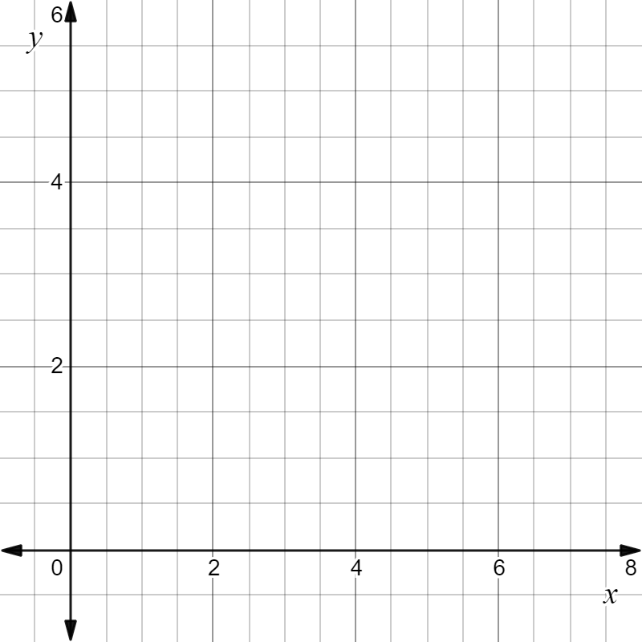

1. The observer is in a hot air balloon directly above the middle coordinate of the longest northwest to southeast distance on the island (assuming island is flat).

If $a$ is a positive constant, show, using calculus, that the observer is directly above the point:

$\left(\frac{3}{8a},\frac{3}{8a}\right)$ 4 marks

|  |
| --- |
|  |
|  |
|  |
|  |
|  |
|  |
|  |
|  |
|  |
|  |
|  |
|  |
|  |
|  |
|  |

1. The angle of depression from the observer in the balloon to the southwest most point on the island was 5.091o. However, when the balloon rose a further 200 m straight upwards, the angle of depression increased to 6.102o. What is the value of *a* to 4 decimal places? Hence, what is the length, to the nearest meter, of the longest northwest to south east distance on the island? 3 marks

|  |
| --- |
|  |
|  |
|  |
|  |
|  |
|  |
|  |
|  |
|  |
|  |
|  |
|  |
|  |
|  |
|  |
|  |

1. While at the final height found achieved in part **f**, a bird crashed into the,

creating a hole. The balloon immediately began to descend at a rate of $\frac{t}{20}$ m/s (where *t* is time in seconds after the hole formed). However, the leaking air also caused it to move north at 12 m/s. Will the balloon land on the island or in the water? Show relevant working to justify your result. 3 marks

|  |
| --- |
|  |
|  |
|  |
|  |
|  |
|  |

**Question 5** (11 marks)

A circle can be placed inside a regular polygon such that it touches each side of the polygon once only. An example is shown below for a hexagon.

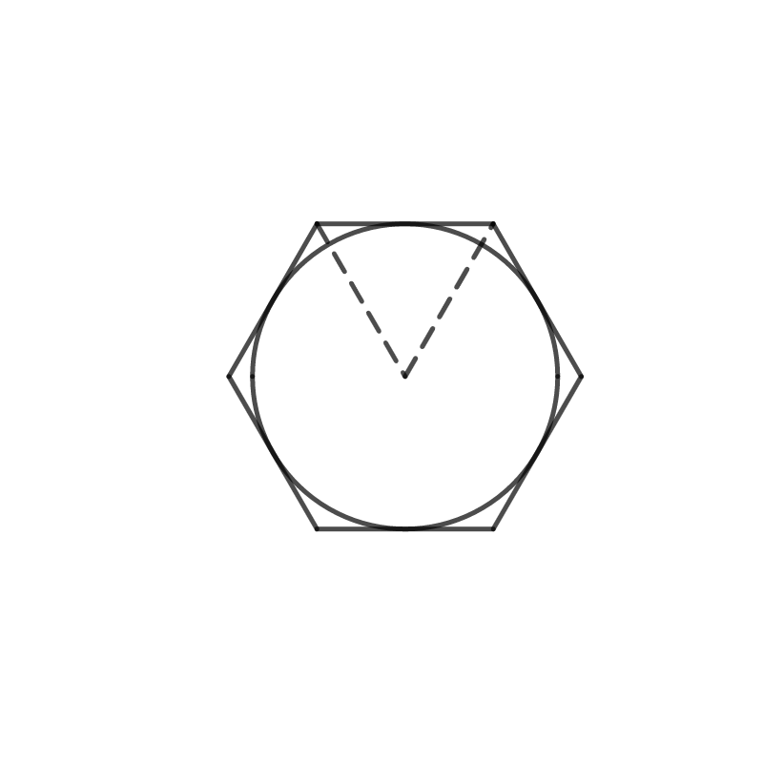

1. Develop an equation that will provide the area of an *n*-sided polygon, such that the radius of the largest circle that can fit into it is 1. 3 marks

|  |
| --- |
| . |
|  |
|  |
|  |
|  |
|  |
|  |
|  |
|  |
|  |
|  |
|  |
|  |

1. Using the equation developed in part **a**., write an expression for the limit as *n* approaches infinity. What is this limit when evaluated? 2 marks

|  |
| --- |
|  |
|  |
|  |

1. What is the expression for the limit as *n* approaches infinity for when the largest

circle that fits inside a regular polygon has a radius of *r*? What is this limit when evaluated?

2 marks

|  |
| --- |
|  |
|  |
|  |

1. Hence, what shape does an *n*-sided polygon become as *n* approaches infinity? 1 mark

|  |
| --- |
| . |
|  |

1. Now let the polygon in part **c**. be the base of an *n*-sided right pyramid.

Develop an equation that gives the total surface area of this *n*-sided pyramid in

terms of *r*, *n* and *h*, where *h* is the height of the pyramid. Evaluate the limit of this

equation as *n* approach infinity, and hence find a formula for the surface area (including base) of a right cone. Express the formula in terms of $r \text{and} L$, where *L* is slant height of the cone. 3 marks

|  |
| --- |
|  |
|  |
|  |
|  |
|  |
|  |
|  |
|  |
|  |
|  |
|  |
|  |
|  |

**END OF QUESTION AND ANSWER BOOK**

**Mathematical Methods Formulas**

**MATHEMATICAL METHODS**

**Written examinations 1 and 2**

**FORMULA SHEET**

Instructions

|  |
| --- |
| This formula sheet is provided for your reference. |

|  |
| --- |
| **Students are NOT permitted to bring mobile phones and/or any other unauthorised electronic devices into the examination room.** |

**Mensuration**

|  |  |  |  |
| --- | --- | --- | --- |
| area of a trapezium | $$\frac{1}{2}\left(x+b\right)h$$ | volume of a pyramid | $$\frac{1}{3}Ah$$ |
| curved surface area of a cylinder | $$2πrh$$ | volume of a sphere | $$\frac{4}{3}πr^{3}$$ |
| volume of a cylinder | $$πr^{2}h$$ | area of a triangle | $$\frac{1}{2}bc\sin\left(A\right)$$ |
| volume of a cone | $$\frac{1}{3}πr^{2}h$$ |  | |

**Calculus**

|  |  |  |  |
| --- | --- | --- | --- |
| $$\frac{d}{dx}\left(x^{n}\right)={nx}^{n-1}$$ | | $$\int{x^{n}dx}=\frac{1}{n+1}x^{n+1}+c, n≠-1$$ | |
| $$\frac{d}{dx}\left({(ax+b)}^{n}\right)={an(ax+b)}^{n-1}$$ | | $$\int{(a{x+b)}^{n}dx}=\frac{1}{a\left(n+1\right)}(a{x+b)}^{n+1}+c, n≠-1$$ | |
| $$\frac{d}{dx}\left(e^{ax}\right)={ax}^{ax}$$ | | $$\int{e^{ax}dx=\frac{1}{a}e^{ax}+c}$$ | |
| $$\frac{d}{dx}\left(\log_{e}\left(x\right)\right)=\frac{1}{x}$$ | | $$\int{\frac{1}{x}dx=\log_{e}\left(x\right)+c}$$ | |
| $$\frac{d}{dx}\left(\sin\left(ax\right)\right)=a\cos\left(ax\right)$$ | | $$\int{\sin\left(ax\right)dx=-\frac{1}{a}cos\left(ax\right)+c}$$ | |
| $$\frac{d}{dx}\left(\cos\left(ax\right)\right)=-a\sin\left(ax\right)$$ | | $$\int{\cos\left(ax\right)dx=-\frac{1}{a}sin\left(ax\right)+c}$$ | |
| $$\frac{d}{dx}\left(\tan\left(ax\right)\right)=\frac{a}{{\text{cos}}^{2}\left(ax\right)}=a\sec^{2}\left(ax\right)$$ | |  | |
| product rule | $$\frac{d}{dx}\left(uv\right)=u\frac{dv}{dx}+v\frac{du}{dx}$$ | quotient rule | $$\frac{d}{dx}\left(\frac{u}{v}\right)=\frac{v\frac{du}{dx}-u\frac{dv}{dx}}{v^{2}}$$ |
| chain rule | $$\frac{dy}{dx}=\frac{dy}{du}\frac{du}{dx}$$ |  | |

**Probability**

|  |  |  |  |
| --- | --- | --- | --- |
|  | |  | |
|  | |  | |
| mean | $$μ=\text{E(}X)$$ | Variance |  |

|  |  |  |  |
| --- | --- | --- | --- |
| **Probability distribution** | | **Mean** | **Variance** |
| discrete | $$\text{Pr(}X=x)=p(x)$$ | $$u=Σxp(x)$$ | $$σ^{2}=\text{E}\left({\left(X-μ\right)}^{2}\right)=\text{E}{\left(X\right)}^{2}-μ^{2}$$ |
| continuous | $$\text{Pr(}a<X<b)=\int_{a}^{b}{f\left(x\right)dx}$$ | $$μ=\int_{-∞}^{∞}{xf\left(x\right)dx}$$ | $$σ^{2}=\int_{-∞}^{∞}{{\left(x-μ\right)}^{2}f\left(x\right)dx}$$ |

**Multiple Choice Answer Sheet**

**Student Name:**

Shade the letter that corresponds to each correct answer.

|  |  |  |  |  |  |
| --- | --- | --- | --- | --- | --- |
| **Question** | **A** | **B** | **C** | **D** | **E** |
| Question 1 |  |  |  |  |  |
| Question 2 |  |  |  |  |  |
| Question 3 |  |  |  |  |  |
| Question 4 |  |  |  |  |  |
| Question 5 |  |  |  |  |  |
| Question 6 |  |  |  |  |  |
| Question 7 |  |  |  |  |  |
| Question 8 |  |  |  |  |  |
| Question 9 |  |  |  |  |  |
| Question 10 |  |  |  |  |  |
| Question 11 |  |  |  |  |  |
| Question 12 |  |  |  |  |  |
| Question 13 |  |  |  |  |  |
| Question 14 |  |  |  |  |  |
| Question 15 |  |  |  |  |  |
| Question 16 |  |  |  |  |  |
| Question 17 |  |  |  |  |  |
| Question 18 |  |  |  |  |  |
| Question 19 |  |  |  |  |  |
| Question 20 |  |  |  |  |  |



**Solution Pathway**

**NOTE: This task is sold on condition that it is NOT placed on any school network or social media site (such as Facebook, Google Dos, etc.) at any time.**

**FOR ADJUSTED STUDY DESIGN (2020 ONLY)**

**NOT FOR PRIVATE TUTOR USE.**

Below are sample answers. Please consider the merit of alternative responses.

**Section A: Multiple-choice answers**

|  |  |  |  |  |  |  |  |
| --- | --- | --- | --- | --- | --- | --- | --- |
| **1.** | **E** | **6.** | **D** | **11.** | **A** | **16.** | **B** |
| **2.** | **D** | **7.** | **B** | **12.** | **C** | **17.** | **E** |
| **3.** | **A** | **8.** | **C** | **13.** | **D** | **18.** | **D** |
| **4.** | **B** | **9.** | **D** | **14.** | **D** | **19.** | **A** |
| **5.** | **A** | **10.** | **E** | **15.** | **E** | **20.** | **C** |

**Section A: Multiple-choice solutions**

**Question 1: E**

Equation is in standard form.

$$Amplitude= \left|a\right|=\left\lceil -\frac{1}{4}\right\rceil =\frac{1}{4}, Period= \frac{2π}{n}=\frac{2π}{1/2}=4π$$

**Question 2: D**

Use Expand function on CAS and read coefficient of the $x^{2}$ term. Coefficient is 6.

**Question 3: A**

Solve $f^{'}\left(x\right)=0$ for *x* using CAS to find *x*-coordinates of turning points. $x=-4, x=3$

Evaluate $f\left(-4\right) \text{and }f\left(3\right)$ to find corresponding *y*-coordinates of turning points.

$$y= -41, \frac{220}{3}$$

**Question 4: B**

$$\text{Apply dilation by a factor of 2 parallel to }x-\text{axis. }$$

$$n=\frac{1}{df}=\frac{1}{2}$$

$$∴f\left(x\right)'=2\sin\left(\frac{x}{2}\right)+6$$

Apply translations of 2 units right, 4 units down.

$$f{\left(x\right)}^{'}=2\sin\left(\frac{1}{2}\left(x-2\right)\right)+2=g(x)$$

**Question 5: A**

The graph is of an exponential function that has been reflected about the *x*-axis and translated vertically $-a$ units. This means its range is from $\left(-∞,-a\right).$ However, from given information, the range is $\left(-∞,4\right)$, which means $-a=4$ and hence $a=-4$.

**Question 6: D**

Integrate by hand or on CAS.

$$\int{2\cos\left(4x\right)-1 dx=\frac{1}{2}\sin\left(4x\right)-x+c}$$

**Question 7: B**

$$\text{Equation 1: }f\left(x\right)=ax-\frac{3}{4} \text{since they intersect at point where line is normal to }f\left(x\right)$$

$$\text{Equation 2: }f^{'}\left(x\right)=-\frac{1}{a} since gradient of f(x) equals negative reciprocal of gradienct of$$

$normal at point where normal intersects f(x)$.

Solve system of equations on CAS.

$$a=\frac{1}{4}, -2-\sqrt{3}, -2+\sqrt{3}$$

**Question 8: C**

Key word is that the inverse is a function and hence must pass the vertical line test. A basic

sketch of $f(x)$ and its reflection about $y=x$ yields a graph as follows:

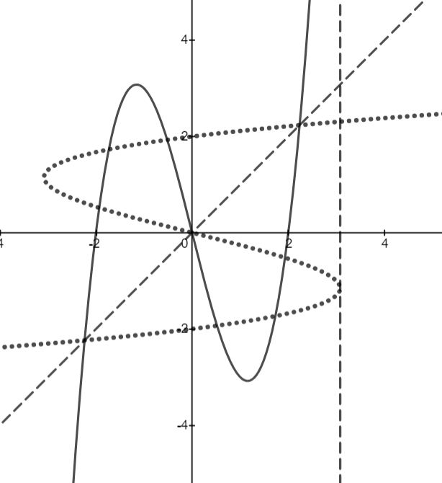

Note that the inverse is a function for *x*-values greater than the turning point in the fourth quadrant (can ignore negative *x*-values since domain of $f(x)$ itself is restricted). This is indicated by a vertical dashed line above. The *x*-coordinate of this turning point corresponds to the *y*-coordinate of the turning point in $f\left(x\right).$ To find this value, solve $f^{'}\left(x\right)=0$ on CAS and select the negative solution.

$$x=-\frac{2\sqrt{3}}{3}$$

$$f\left(-\frac{2\sqrt{3}}{3}\right)=\frac{16\sqrt{3}}{9}$$

$$\text{Therefore maximum domain is }x∈\left(\frac{16\sqrt{3}}{9},∞\right)$$

**Question 9: D**

Consider option A: $f\left(c\right)=0$ and $f^{'}\left(x\right)>0$ when $x>c$

$c$ is an *x*-intercept and so $f\left(c\right)=0$ and gradient is positive for $x>c$. Therefore option A is true.

Consider option B: $f\left(x\right)<0$ when $x<a$ and $f^{'}\left(x\right)>0$ when $x<a$

Graph is below *x*-axis for $x<a$, so $f\left(x\right)<0$. Gradient is positive for $a<x,$ so $f^{'}\left(x\right)>0$. Therefore option B is true.

Consider option C: $f\left(x\right)>0$ when $x>c$ and $f^{'}\left(x\right)>0$ when $x>c$

Graph is above *x*-axis for $x>c$ so $f\left(x\right)>0$. Gradient is positive when $x>c$ so $f'\left(x\right)>0$ when $x>c$. Therefore option C is true.

Consider option D: $f\left(b\right)=0$ and $f^{'}\left(x\right)>0$ when $x>a$

$b$ is an *x*-intercept and so $f\left(b\right)=0$. For $x>a$, gradient is positive is some sections and negative in others, therefore $f^{'}\left(x\right)>0$ when $x>a$ is false. Therefore option D is false.

Consider option E: $f\left(a\right)=0$ and $f^{'}\left(x\right)>0$ when $x>c$

$a$ is an *x*-intercept and so $f\left(a\right)=0$. Gradient is positive for $x>c$ so $f^{'}\left(x\right)>0$ when $x>c$. Therefore option E is true.

Only option D is false.

**Question 10: E**

The area needs to be determined as the sum of two definite integrals. Since the area between $a \text{and }b$ is positive, it can be determined by evaluating the definite integral:

$$\int_{a}^{b}{f\left(x\right)dx}$$

Since the area between $b \text{and }c$ is negative, it can be determined by evaluating any of the following definite integrals:

$$-\int_{b}^{c}{f\left(x\right)dx} \text{or }\int_{c}^{b}{f\left(x\right)dx} \text{or }\left|\int_{b}^{c}{f\left(x\right)dx}\right|$$

Only option E has the first integral and one from the second set above.

**Question 11: A**

Solve using CAS solve function and restrict domain.

$$x=\frac{10}{3},x= \frac{26}{3},x=\frac{34}{3}$$

**Question 12: C**

Binomial distribution problem. $p=0.5, n=10.$ Need $\text{Pr(}X≤3).$ Use the BinomialCdf function on CAS to evaluate. $\text{Pr(}X≤3)=0.1719$

**Question 13: D**

Normal distribution problem. Mean is 7.50.

Since 27% of sheep produce a mass between 7.10 and 7.50 kg, or between 7.10 kg and the mean, it follows, by the symmetry of the normal distribution, that 23% of sheep produce a mass less than 7.10 kg. Using the standard normal distribution with the Inverse Normal function of the CAS, the number of standard deviations, below which the lower 23% of the data occupies, can be determined. This turns out to be -0.7388. That is, $\text{Pr(}X<7.1)=\text{Pr(}Z<-0.7388)$.

From this, the standard deviation of the wool mass distribution can be determined.

$$Z=\frac{x-μ}{σ}$$

$$∴σ=\frac{x-μ}{Z}=\frac{7.1-7.5}{-0.7388}=0.5414$$

Finally, use the distribution parameters and the NormalCdf function of the CAS to determine $\text{Pr(}X>8.25).$

$$\text{Pr(}X>8.25\left|μ=7.5,σ=0.5414\right)= 0.0830$$

**Question 14: D**

$$\text{Pr}\left(Z<a | Z>b\right)=\frac{\text{Pr}(Z<a ∩Z>b)}{\text{Pr(}Z>b)}$$

$Z<a ∩Z>b$ corresponds to the shaded region in the graph below. Note that the actual positions of *a* and *b* are not important, just that $a>b$. From the given information,

$\text{Pr(}Z<a)=1-m$ and $\text{Pr(}Z<b)=n.$

Therefore, $\text{Pr}\left(Z<a ∩Z>b\right)=\text{Pr(}Z<a)-\text{Pr(}Z<b)=1-m-n$

$$\text{Therefore }\text{Pr}\left(Z<a | Z>b\right)=\frac{\text{Pr}(Z<a ∩Z>b)}{\text{Pr(}Z>b)}=\frac{1-m-n}{1-n}=\frac{m+n-1}{n-1}$$

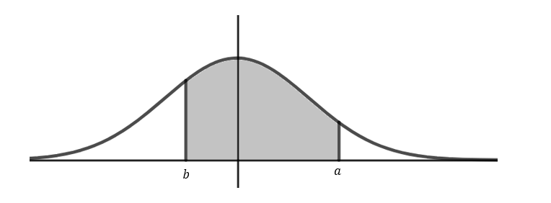

**Question 15: E**

Using the tangent line function on the CAS, the equation of the tangent at $x=b$ is

$$y=\frac{ax}{2\sqrt{b}}+\frac{a\sqrt{b}}{2}$$

Using the normal line function on the CAS, the equation of the normal at $x=4b$ is

$$y=\frac{2\left(a^{2}+8b\right)\sqrt{b}}{a}-\frac{4\sqrt{b}x}{a}$$

Set up a pair of simultaneous equations, using the given information that they intersect at $\left(7, 9\sqrt{2}\right).$

$$\left\{\begin{aligned}y=\frac{ax}{2\sqrt{b}}+\frac{a\sqrt{b}}{2} \\ y=\frac{2\left(a^{2}+8b\right)\sqrt{b}}{a}-\frac{4\sqrt{b}x}{a}\end{aligned}|x=7, y=9\sqrt{2}\right.$$

$$a=4, b=2$$

**Question 16: B**

A typical graph of *y* is shown below.

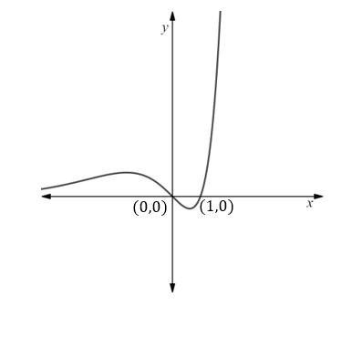

Let *A1* be the area between the curve (for $x<0)$ and the $x-\text{axis}$.

$$A1=\int_{-∞}^{0}{a(x^{2}-x)e^{x} dx}=3a$$

Let *A2* be the area between the curve (for $0≤x≤1)$ and the $x-\text{axis}$. This area is below the *x*-

axis, so multiply by negative 1 (sine area must be positive).

$$A1=-\int_{0}^{1}{a(x^{2}-x)e^{x} dx}=-a(e-3)$$

The graph would be reflected about the *x*-axis if *a* was negative, and so A1 would have to be multiplied by negative 1 instead. Ratio will be the same though.

$$\frac{A1}{A2}=\frac{3}{-a(e-3)}=\frac{3}{3-e}$$

**Question 17: E**

$$f\left(x\right)=x^{m/n} \text{and }g\left(x\right)=x^{p/q}, m, n,p,q∈N$$

$$h\left(x\right)=f\left(g\left(x\right)\right)={\left(x^{p/q}\right)}^{m/n}=x^{{pm}/{qn}}$$

Consider option A: For $n<m \text{and }q<p$ and $x<0,$ then $h^{'}\left(x\right)>0$

Is there an example that makes statement untrue? Yes, for example, if numerator of index of $h(x)$ is even and denominator is odd, then $h^{'}\left(x\right)<0, x<0.$

Consider option B: For $n>p$ and $m<q$ and $x>0$, then $h^{''}\left(x\right)>0$

This means the denominator of the index of $h(x)$ is greater than the numerator. If $h^{''}\left(x\right)>0$, the gradient is increasing as *x*-increases. Is there an example which makes this untrue? Yes, for example, if numerator of index of $h(x)$ is even and denominator is odd, then $h^{''}\left(x\right)<0, x≠0.$

Consider option C: $h(x)$ is defined for $x∈R$

Is there an example which makes this untrue? Yes, when the denominator is even, since this would require taking an even *n*th root and these don’t exist for negative *x*-values.

Consider option D: $h^{'}\left(1\right)=\frac{nq}{mp}$ $$h^{'}\left(x\right)=\frac{mp}{nq}x^{\frac{mp}{nq}-1}$$

Therefore $h^{'}\left(1\right)=\frac{mp}{nq}$ so not true

Consider option E: $For m=q and p=n, \text{then }\left(m,m\right) and \left(n,n\right) are points on h(x)$

If $m=q and p=n$ then $h\left(x\right)$ breaks down to $h\left(x\right)=x$, which means that $h\left(x\right)=x$ for all *x*. So true.

**Question 18: D**

$$f^{'}\left(0\right)=1, \text{therefore angle tangent makes with }x\text{-axis is }\tan^{-1}\left(1\right)=\frac{π}{4}$$

$$\text{By symmetry, }g^{'}\left(0\right)=-1, \text{therefore angle tangent makes with }x\text{-axis is -}\frac{π}{4}$$

$$\text{Angle between the two tangents therefore is }\frac{π}{2}$$

**Question 19: A**

Find expression for $x\text{-}$ intercepts of $h(x)$ as these are the terminals.

Solve $h\left(x\right)=0$

$$∴x=b±4\sqrt{c}$$

Set up equation involving average value of a function formula and solve on CAS for *c*, the

*y*-coordinate of the turning point and hence the maximum height.

$$\frac{1}{\left(b+4\sqrt{c}\right)-(b-4\sqrt{c})}\int_{b-4\sqrt{c}}^{b+4\sqrt{c}}{h\left(x\right)dx}=\frac{50}{3}$$

$$c=25$$

**Question 20: C**

$$\text{If }f\left(x\right)=x^{\frac{1}{3}}, \text{then the graph of }g\left(x\right), \text{where }g\left(x\right)=1-2f\left(1-2x\right) \text{could be}:$$

$$\text{Compared to }f\left(x\right), g\left(x\right)\text{ has been reflected about both axes, dilated by a factor of 2 parallel }$$

$\text{to the }y\text{-axis and 1/2 parallel to the }x\text{-axis, as well as translated up 1 and right 1/2. }$ This means it will have a basic orientation similar to $f(x)$, since the two reflection cancel one another for this type of function. This excludes options A and B. The translations mean that the point of inflection will be in the first quadrant and so option C.

**Section B: Extended Answer Solutions**

**Question 1** (10 marks)

Let $f:\left(a,b\right)→R:f\left(x\right)=x\log_{e}\left(x\right)$

1. **i.** Let $g\left(x\right)=x \text{and }h\left(x\right)= \log_{e}\left(x\right).$ 1 mark

$Maximum domain of f\left(x\right)=\text{dom }g\left(x\right)∩h\left(x\right)=\left(0,∞\right).$ Therefore *a* =0.

**ii. $f^{'}\left(x\right)=\log_{e}\left(x\right)+1$** 1 mark

1. Solve $f^{'}\left(x\right)=0$ $$∴x=\frac{1}{e} \\ At x=\frac{1}{e}, f\left(\frac{1}{e}\right)=-\frac{1}{e} \\ ∴ \text{Stationary point at}\left(\frac{1}{e},-\frac{1}{e}\right)$$ 
   From graph, it is a local minimum. Alternatively, $f\left(0\right)=f\left(1\right)=0,$ 2 marks

which are both points on either side of the stationary point and are greater than *y*-coordinate of stationary point, indicating that the stationary point is a local minimum.

1. 3 marks
$$\frac{d}{dx}\left(x^{2}\log_{e}{(x}\right))=2x\log_{e}\left(x\right)+x$$

$$∴\int{2x\log_{e}\left(x\right)+xdx=}x^{2}\log_{e}{(x})+c$$

$$\int{2x\log_{e}\left(x\right)dx+\int{xdx}=}x^{2}\log_{e}{(x})+c$$

$$\int{2x\log_{e}\left(x\right)dx=}x^{2}\log_{e}{(x})-\int{xdx}+c$$

$$\int{x\log_{e}\left(x\right)dx=}{\frac{1}{2}x}^{2}\log_{e}{(x})-\frac{1}{2}\int{xdx}+c$$

$$\int{x\log_{e}\left(x\right)dx=}{\frac{1}{2}x}^{2}\log_{e}{(x})-\frac{1}{4}x^{2}+c$$

2. The $x-$ intercept of $f(x)$ is at (1,0), so $k=1$ because $f(x)$ is not defined at (0, 0)

and so this cannot be considered as an $x-$ intercept. The graph below summarised the problem. The area below the $x-$ axis must equal the area of the shaded region above the $x-$ axis. 3 marks

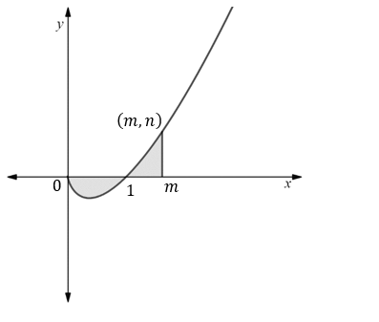

Set up an equation equating the two areas and solve for *m*, taking into account that the area below the *x*-axis is negative and so must have its sign changed in the equation.

$$\int_{1}^{m}{f\left(x\right)dx=-\int_{0}^{1}{f(x)}}$$

$$m=\sqrt{e}$$

$$\text{Now } f\left(\sqrt{e}\right)=\sqrt{e}\log_{e}\left(\sqrt{e}\right)$$

$$=\sqrt{e}\log_{e}\left(e^{1/2}\right)$$

$$=\frac{1}{2}\sqrt{e}$$

$$∴n =\frac{1}{2}\sqrt{e}$$

**Question 2** (10 marks)

At the factory, employees currently work 12 hour shifts. A defective seal is one that fails to meet quality control criteria, and therefore cannot be sold. The manager noticed that the number of defective seals (*D*) an employee makes per hour can be modelled by the following equation:

$$\frac{dD}{dt}=8-2\sin\left(\frac{π\left(t+6\right)}{12}\right), 0≤t≤12$$

1. 1 mark

**i.** This will be when:

$$\sin\left(\frac{π\left(t+6\right)}{12}\right)=1$$

$$∴\frac{π\left(t+6\right)}{12}=\frac{π}{2}$$

$∴t=0$ which is 6 am

**ii.** This will be when: 1 mark

$$\sin\left(\frac{π\left(t+6\right)}{12}\right)=-1$$

$$∴\frac{π\left(t+6\right)}{12}=\frac{3π}{2}$$

$∴t=12$ which is 6 pm

1. Find an equation that will provide the number of defective seals, *D*, an employee will make as a function of time. How many defective seals will an employee make throughout the course of an entire shift? 3 marks

$$\frac{dD}{dt}=8-2\sin\left(\frac{π\left(t+6\right)}{12}\right)$$

$$∴D=\int{\frac{dD}{dt}dt}=8t-\frac{24}{π}\sin\left(\frac{πt}{12}\right)+c$$

At $t=0, D=0$

$$8×0-\frac{24}{π}\sin\left(\frac{π×0}{12}\right)+c=0$$

$$0+c=0$$

$$c=0$$

$$∴D=8t-\frac{24}{π}\sin\left(\frac{πt}{12}\right)$$

For 1 shift, $t=12$:

$$D=8×12-\frac{24}{π}\sin\left(\frac{π×12}{12}\right)=96 \text{defects}$$

$$\text{Alternatively}$$

$$D=\int_{0}^{12}{8-2\sin\left(\frac{π\left(t+6\right)}{12}\right)dt}=96 defects$$

2. Show that the profit, *P*, the company makes from an employee over the 2 marks

Course of a shift can be modelled by the equation:

$$P\left(x\right)=55t-\frac{2}{45}{\left(8t-\frac{24}{π}sin\left(\frac{πt}{12}\right)\right)}^{2}, 0≤t≤12$$

Profit = Revenue - Expenses

$$Revenue= R\left(t\right)=4\left(20t-\frac{1}{90}{\left(D(t)\right)}^{2}\right)=4\left(20t-\frac{1}{90}{\left(8t-\frac{24}{π}\sin\left(\frac{πt}{12}\right)\right)}^{2}\right)$$

$$\text{Expenses}=25t$$

$$\text{∴Profit =}4\left(20t-\frac{1}{90}{\left(8t-\frac{24}{π}\sin\left(\frac{πt}{12}\right)\right)}^{2}\right) -25t$$

$$\text{ =}80t-\frac{2}{45}{\left(8t-\frac{24}{π}\sin\left(\frac{πt}{12}\right)\right)}^{2} -25t$$

$$\text{ =}55t-\frac{2}{45}{\left(8t-\frac{24}{π}\sin\left(\frac{πt}{12}\right)\right)}^{2}$$

1. Check graph of profit function (below). From the graph, it can be seen that maximum profit occurs at the local maximum. 3 marks

$$\text{Solve }\frac{dP}{dt}=0$$

$$t=8.92735$$

$\text{Therefore, to maximise profit, shift duration should be }8.93 \text{h to 2 decimal places}$.

Maximum profit $=P\left(8.93\right)=\$297.90$

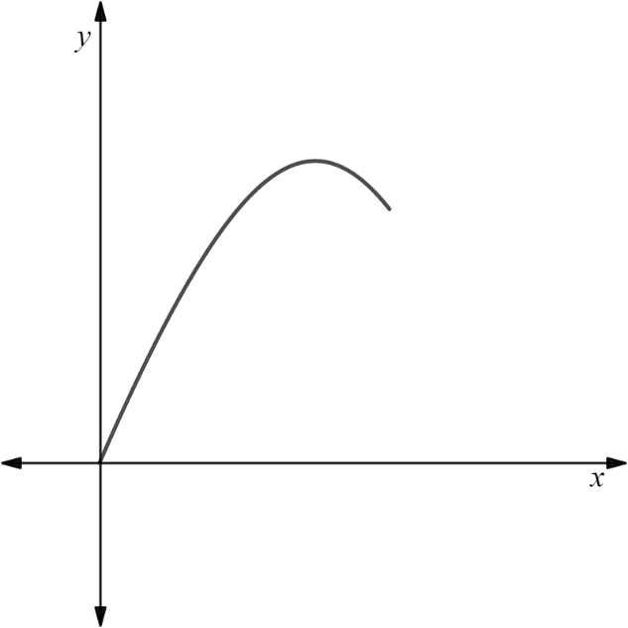

**Question 3** (13 marks)

Safeflush also manufactures flush mechanisms. Before shipment, mechanisms are randomly selected and tested for defects. The number of defects in a batch is normally distributed. There are 1,000 flush mechanisms in each batch.

From each batch, 50 mechanisms are sampled and tested. The batch will be delivered to the retailer if not more than 3 of these mechanisms are defective. The average number of defects per *sample* is 1.5.

**i. $Average number of defects per batch= \frac{1.5}{50}×1000=30$** 1 mark

**ii. $\text{\% Defects =}\frac{1.5}{50}×100=3\%$** 1 mark

1. 3% defects corresponds to 60 mechanisms. This means that 10% of batches 2 marks

have more than 60 defects. This means that 90% of the batches have less than 60 defects. Thus, if *D* is a random variable that models the distribution of defects per batch, then $\text{Pr}\left(D<60\right)=0.9$. Use Inverse Normal function on the CAS to find the number of standard deviations above the mean this corresponds to.

$Z=1.2816.$ Using the formula for calculating *Z*, the standard deviation of *D* can be determined.

$$Z=\frac{x-μ}{σ}$$

$$σ=\frac{x-μ}{Z}=\frac{60-30}{1.2816}=23.408$$

1. **i. $\text{Pr}\text{(}D<5)|μ=30, σ=23.408=0.1428$** 1 mark
2. $\text{Pr}\text{(20<}D<30)|μ=30, σ=23.408=0.1654$ 1 mark

**iii. $\text{Pr}\text{(}D>30\left|D>20\right)|μ=30, σ=23.408$** Use conditional probability formula. 2 marks

$$=\frac{\text{Pr(}D>30∩D>20)}{Pr⁡(D>20)}$$

$$=\frac{\text{Pr(}D>30)}{Pr⁡(D>20)}=\frac{0.5}{0.6654}=0.7514$$

1. $\text{Pr(}D<60)=0.9000$ from previously. The is a binomial distribution problem. Let *P* be a random variable that represents the probability distribution of pass/fail quality control check on any given day.

**i.** all of the batches pass the quality control check? 1 mark

$$\text{Pr(}P=5)=\text{nCr(5,5)×}p^{5}{\{1-p)}^{0}$$

$$=0.59049$$

**ii.** none of the batches pass the quality control check? 1 mark

$$\text{Pr(}P=0)=\text{nCr(5,0)×}p^{0}{(1-p)}^{5}=0.00001$$

1. $\text{Solve Pr(}P=5)=\text{nCr(5,5)×}p^{5}{\{1-p)}^{0}=0.75$ 3 marks $$p=0.9441$$

Therefore the probability that a batch will pass the quality control test needs to be increased from 0.90 to 0.9441.

$\text{∴Pr(}D<60)=0.9441$ given $μ=30$

Use inverse normal to determine Z, the number of standard deviations above the mean this corresponds to:

$\text{If Pr}(Z<0.9441)$ then *Z* = 1.5902

$$Z=\frac{x-μ}{σ}$$

$$σ=\frac{x-μ}{Z}=\frac{60-30}{1.5902}=18.866$$

**Question 4** (16 marks)

One of the curves that models the shape of the island is $y=ax^{2},$ where *a* is a positive real number. The other curve has an equation corresponding to the inverse of y.

1. $\text{Let }x={ay}^{2}, ∴y=\sqrt{\frac{x}{a}}, ∴y^{-1}=\sqrt{\frac{x}{a}}$ 1 mark
2. $dom:\left[0,∞\right\}ran:[0,∞)$ 2 marks
3. Since it must be the point of intersection, solve: 1 mark

$$\left\{\begin{aligned}y=\sqrt{\frac{x}{a}}, \\ y={ax}^{1}\end{aligned}\right. ∴ \text{most north eastern point is }\left(\frac{1}{a},\frac{1}{a}\right)$$

Alternatively, recognise that for inverse, the point of intersection also intersects $y=x$, and replace one of the equations above with $y=x$

1. Correct shape of each, point of intersection labelled, graphs identified. 3 marks

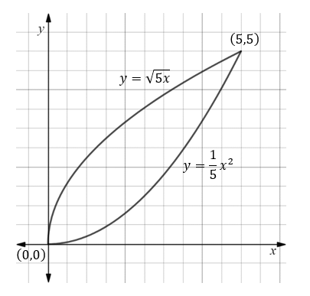

1. $\text{Let }y=f\left(x\right), \text{Let }y^{-1}=g(x)$ 4 marks

The north west end of the line will be a point on $g(x)$.

Let this point be $(x,g\left(x\right))$

Since the line runs northwest to south east, and since the *y*-axis corresponds to due north, the gradient of the line must be -1.

Therefore, the coordinate of the point where this line intersects $f\left(x\right),$ the inverse of $g\left(x\right),$ is $(g\left(x\right), x)$. This can be shown in other ways, such as finding the equation of the line and then its point of intersection with $f\left(x\right).$

Let $D\left(x\right)= \text{The length of the line from northwest to southeast}$

$$∴D\left(x\right)=\sqrt{(y_{2}-y_{1})^{2}+(x_{2}-x_{1})^{2}}$$

$$=\sqrt{{(x-g\left(x\right))}^{2}+{(g\left(x\right)-x)}^{2}}$$

$$=\sqrt{2(g\left(x\right)-x)^{2}}$$

$$=\sqrt{2}\left[g\left(x\right)-x\right]$$

Now solve $D^{'}\left(x\right)=0$ given $0<x<\frac{1}{a} \text{and }a>0$

$$∴x=\frac{1}{4a}$$

$This is x-\text{coordinate of }the north west most point of the line$.

$$\text{The }y\text{-coordinate is }g\left(\frac{1}{4a}\right)=\frac{1}{2a}$$

$$∴ \text{NW point is }\left(\frac{1}{4a},\frac{1}{2a}\right)$$

Therefore, the south east coordinate of the line, where it intersects $f(x)$ is:

$$\left(\frac{1}{2a},\frac{1}{4a}\right)$$

Need to find the midpoint of this line, as that is the point above which the balloon lurks.

$$\text{Let }\left(x_{1},y_{1}\right)=\left(\frac{1}{4a},\frac{1}{2a}\right)$$

$$\text{Let }\left(x_{2},y_{2}\right)=\left(\frac{1}{2a},\frac{1}{4a}\right)$$

Therefore, *M*, the midpoint, can be found using the midpoint formula.

$$M=\left(\frac{x_{2}+x_{1}}{2},\frac{y_{2}+y_{1}}{2}\right)$$

$$=\left(\frac{\frac{1}{4a}+\frac{1}{2a}}{2},\frac{\frac{1}{2a}+\frac{1}{4a}}{2}\right)=\left(\frac{3}{8a},\frac{3}{8a}\right)$$

1. Let the first height of the balloon be *h*. Therefore, the second height of 3 marks

the balloon is $h+0.2$ (since distances are in km). The distance along the ground from directly below the balloon to the south west end of the island can be determined using Pythagoras. Let this distance be *d*.

$$d=\sqrt{{\left(\frac{3}{8a}\right)}^{2}+{\left(\frac{3}{8a}\right)}^{2}}=\frac{3}{4\sqrt{2}a}$$

The situation is represented in the diagram below.

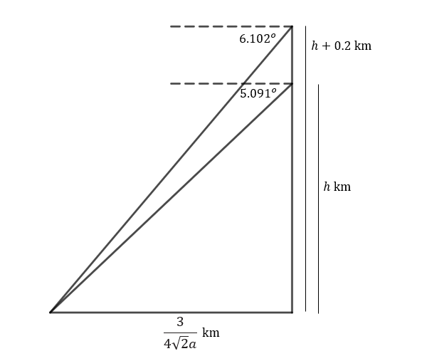

Set up a pair of simultaneous equations.

$$\left\{\begin{aligned}\tan\left(5.091\right)=\frac{8ah}{3\sqrt{2}} \\ \tan\left(6.102\right)=\frac{8a(h+0.2)}{3\sqrt{2}}\end{aligned}\right.$$

Solving this system of equations for when $\text{, }a=0.0472$ to 4 decimal places, and $h=1 \text{km}$.

From part **e**. Length of north east line:

$$D\left(x\right)=\sqrt{2}\left(g\left(x\right)-x\right) where a=0.0472 and x=\frac{1}{4a} \text{for maximum length}$$

Therefore, maximum north west to south east length is 7.491 km to nearest meter.

1. While at the final height found achieved in part **f**, a bird crashed into the balloon, 2 marks

creating a hole. The balloon immediately began to descend at a rate of $\frac{t}{20}$ m/s (where *t* is time in seconds after the hole formed). However, the leaking air also caused it to move north at 12 m/s. Will the balloon land on the island or in the water? Show relevant working to justify your result.

First need to determined how long it will take for balloon to reach the ground.

Let down be negative

$$∴\frac{dV}{dt}=-\frac{t}{20}$$

$$∴S=\int{\frac{dV}{dt}dt}=\int{-\frac{t}{20}dt=-\frac{1}{40}t^{2}+c}$$

$\text{At }t=0, S=1200$ from part **f**.

$$∴1200=-\frac{1}{40}×0+c$$

$$c=1200$$

$$S=1200-\frac{1}{40}t^{2}$$

Find time when balloon will reach the ground. ie when *S* = 0

$$0=1200-\frac{1}{40}t^{2}$$

$t=40\sqrt{30}$ s

If the balloon is moving north at 12 m/s, then in $40\sqrt{30}$ s it will travel north 480 $\sqrt{30}$ m, or approximately 2629.1 m or 2.629 km.

Now need to determine if this will place balloon in the water or on land.

The *x*-coordinate of the balloon at *t* = 0 is:

$$\frac{3}{8a}=\frac{3}{8×0.0472}=7.945 \text{km}$$

And therefore the corresponding *y*-coordinate is also 7.945 km.

The *y*-coordinate of the coast due north of this point is:

$g\left(7.945|a=0.0472\right)=12.974$ km

This means the balloon must travel north a distance of 5.029 km in order to reach the coast. Given it will only travel 2.629 km, it can be concluded that the balloon will land on the island, a distance of 2.629 km north of the point directly below its initial position.

**Question 5** (11 marks)

1. The triangle below corresponds to one of the triangles created from an 3 marks

*n*-sided polygon as shown in the example. $\overline{OC}$ is the angle bisector of $∠AOB$.

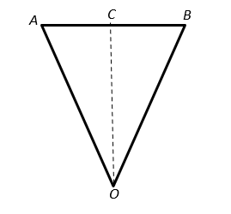

Point *C* intersects the circle inside the polygon and hence the length of $\overline{OC}$ is 1 unit.

$$∠BOC=\frac{1}{2}∠AOB=\frac{1}{2}×\frac{2π}{n}=\frac{π}{n}$$

To get the area of $∆OAB$, we need length $\overline{AB}.$

$$By trigonometry,\overline{AB}=2\overline{AC}=2\overline{OC}\tan\left(\frac{π}{n}\right)$$

$$∴\text{Area of }∆OAB=\frac{1}{2}bh=\frac{1}{2}×2\overline{OC}\tan\left(\frac{π}{n}\right)×\overline{OC}={\overline{OC}}^{2}\tan\left(\frac{π}{n}\right)$$

But $\overline{OC}=1$ here.

$$∴\text{Area of }∆OAB=\tan\left(\frac{π}{n}\right)$$

In an *n*-sided polygon, there are *n* congruent triangles. Therefore, the sum of the areas of these triangles is equal to the area of the polygon. That is:

$$\text{Area of }\text{n}\text{-sided polygon }=n\tan\left(\frac{π}{n}\right)$$

1. Using the equation developed in part **a**., write an expression for the limit

as *n* approaches infinity. What is this limit when evaluated? 2 marks

$$\lim_{n→∞}{n\tan\left(\frac{π}{n}\right)}$$

Evaluate on CAS. When evaluated, the limit is $π$ square units. Which is the area of the circle of radius 1 contained within the polygon.

1. What is the expression for the limit as *n* approaches infinity for when the largest

circle that fits inside a regular polygon has a radius of *r*? What is this limit when

evaluated? 2 marks

$$From part a.∴\text{Area of }∆OAB={\overline{OC}}^{2}\tan\left(\frac{π}{n}\right)$$

$$\text{Let }\overline{OC}=r$$

$$∴\text{Area of }∆OAB=r^{2}\tan\left(\frac{π}{n}\right)$$

$$∴\text{Area of }n-\text{sided polygon}={nr}^{2}\tan\left(\frac{π}{n}\right)$$

$$\lim_{n→∞}{nr^{2}tan\left(\frac{π}{n}\right)}$$

Evaluate on CAS. When evaluated, the limit is $πr^{2}$ square units. Which is the area of a circle of radius *r*.

1. A circle. 1 mark
2. In parts **a**-**d** area for the base was determined using a limit. For an n-sided cone, 3 marks

We have the following situation.

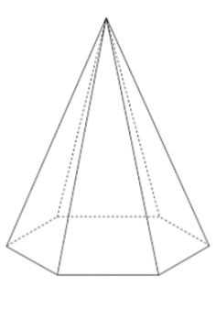

When the sloping sides are folded outwards so that they are in the same plane as the base, the situation is as follows:

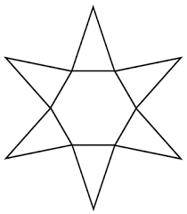

From here, it is apparent that the problem is merely an extension of the problem already addressed with the base.

Let the height of the pyramid be *h*.

One of the triangle in the diagram above is shown below and labelled.

$$D$$

$$L$$

$$B$$

$$A$$

$$2r\tan\left(\frac{π}{n}\right)$$

`

`

`

`

`

From previously, we know that if the radius of the largest circle inside the n-sided polygon is r, then the length of each edge is:

$$2r\tan\left(\frac{π}{n}\right)$$

The height of the triangle here is *L*, the slant height. We need to express *L* in terms of *h* and *r*.

Using Pythagoras’ theorem.

$$L=\sqrt{r^{2}+h^{2}}$$

Therefore, the area of one of the sloping triangles of an *n*-sided pyramid is:

$$\text{Area}=\frac{1}{2}bh=\frac{1}{2}×2r\tan\left(\frac{π}{n}\right)×\sqrt{r^{2}+h^{2}}$$

$$=r\sqrt{r^{2}+h^{2}} tan\left(\frac{π}{n}\right)$$

Therefore, the area of all *n* sloping triangles of an *n*-sided pyramid is:

$$Area=nr\sqrt{r^{2}+h^{2}} tan\left(\frac{π}{n}\right)$$

The limit as the number of sides approaches infinity can be expresses as:

$$\lim_{n→∞}{nr\sqrt{r^{2}+h^{2}} tan\left(\frac{π}{n}\right)}$$

When evaluated using CAS, this gives $πr\sqrt{r^{2}+h^{2}}$

However, $L=\sqrt{r^{2}+h^{2}}$

Therefore, the limit is $πrL$, which is the formula for the area of the sloped section of a cone. When coupled with the base, determined previously, the total surface area of the cone is:

$$\text{Area}={πr}^{2}+πrL$$